* **INTERDOUCE ENGINER**

**WHAT IS AN ENGINEER**?

The [American Engineers' Council for Professional Development](https://en.wikipedia.org/wiki/American_Engineers%27_Council_for_Professional_Development) (ECPD, the predecessor of [ABET](https://en.wikipedia.org/wiki/Accreditation_Board_for_Engineering_and_Technology))[[4]](https://en.wikipedia.org/wiki/Engineering#cite_note-ABET_History-4) has defined "engineering" as:

The creative application of scientific principles to design or develop structures, machines, apparatus, or manufacturing processes, or works utilizing them singly or in combination; or to construct or operate the same with full cognizance of their design; or to forecast their behavior under specific operating conditions; all as respects an intended function, economics of operation and safety to life and property.[[5]](https://en.wikipedia.org/wiki/Engineering#cite_note-ECPD_Canons-5)[[6]](https://en.wikipedia.org/wiki/Engineering#cite_note-ECPD_Definition_on_Britannica-6)

**Table of Contents**



* [#1 Aerospace Engineering](https://engineercalcs.com/types-of-engineering/#1_Aerospace_Engineering)
* [#2 Agricultural Engineering](https://engineercalcs.com/types-of-engineering/#2_Agricultural_Engineering)
* [#3 Audio Engineering](https://engineercalcs.com/types-of-engineering/#3_Audio_Engineering)
* [#4 Bioengineering](https://engineercalcs.com/types-of-engineering/#4_Bioengineering)
* [#5 Chemical Engineering](https://engineercalcs.com/types-of-engineering/#5_Chemical_Engineering)
* [#6 Civil Engineering](https://engineercalcs.com/types-of-engineering/#6_Civil_Engineering)
* [#7 Computer Engineering](https://engineercalcs.com/types-of-engineering/#7_Computer_Engineering)
* [#8 Electrical Engineering](https://engineercalcs.com/types-of-engineering/#8_Electrical_Engineering)
* [#9 Environmental Engineering](https://engineercalcs.com/types-of-engineering/#9_Environmental_Engineering)
* [#10 Geotechnical Engineering](https://engineercalcs.com/types-of-engineering/#10_Geotechnical_Engineering)
* [#11 Industrial Engineering](https://engineercalcs.com/types-of-engineering/#11_Industrial_Engineering)
* [#12 Materials Engineering](https://engineercalcs.com/types-of-engineering/#12_Materials_Engineering)
* [#13 Mechanical Engineering](https://engineercalcs.com/types-of-engineering/#13_Mechanical_Engineering)
* [#14 Ocean / Marine Engineering](https://engineercalcs.com/types-of-engineering/#14_Ocean_Marine_Engineering)
* #15 Mining Engineering

## CHMICAL ENGINEER

* Chemical engineers apply key principles of mathematics, biology, chemistry, and physics to create and manufacture various products. Whereas some professionals in the field work at refineries to transform crude oil into products such as asphalt, heating oil, gasoline, and lubricating oil, others work at companies that convert other raw materials, such as beeswax, into candles, home and body creams, and furniture polish.

Although some job duties for chemical engineers, such as estimating production costs, are uniform across the field, others can vary widely depending on the company. Common daily duties may include:

* Conducting tests and monitoring the performance of various processes
* Troubleshooting problems that arise in the manufacturing process
* Developing methodologies for separating components in gasses and liquids
* Conducting research designed to improve manufa ctu
* systems, materials, structures, and control systems.

AEROSAPCE ENGINEER

an aerospace engineer specializes in the design, development, and maintenance of aircraft, spacecraft, satellites, and other related systems. They apply principles of physics, mathematics, and engineering to create and improve aerospace technologies. These engineers work on various aspects of aerospace engineering, including aerodynamics, propulsion systems, materials, structures, and control systems.

Aerospace engineers collaborate with other professionals, such as scientists, technicians, and manufacturers, to address technical challenges and optimize the performance of aerospace vehicles. Their work advances aviation and space exploration, contributing to the development of more efficient, safer, and technologically advanced aircraft and spacecraft...

* ELECTRICAL ENGINEERING

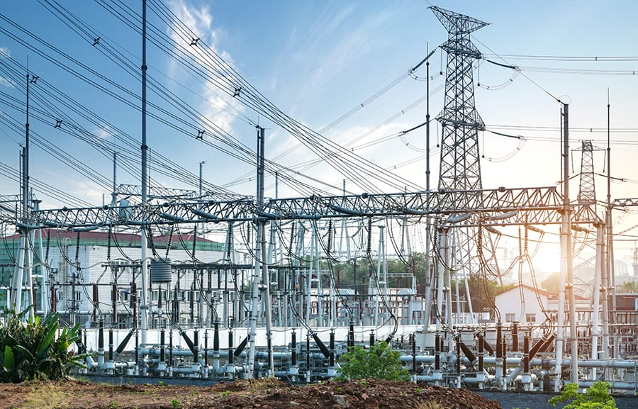

As a kid, I was captivated by Nikola Tesla and his electrifying experiments. Nowadays, it’s hard to imagine life without electricity – no lights, smartphones, internet, refrigerated food, or power. Sounds like a nightmare, right?

[**Electrical engineering has come a long way and now thrives**](https://engineercalcs.com/will-automation-destroy-future-electrical-engineering-jobs/) with these subfields:

* **Communication:** Designing systems and equipment to transmit data.
* **Controls:** Making systems efficient and predictable.
* **Electronics:** Designing and developing electronic components.
* **Power:** Generating, transmitting, and distributing power.

### **Cool jobs:**

* **Power grid:** Managing the U.S. power grid, the largest machine on Earth, and a complex yet outdated electrical system.
* **Signal processing:** Optimizing signals for various use cases.
* **Renewable energy sources:** Enhancing clean energy tech.
* **Industrial automation:** Aiding the transition from human labor to machine automation.
* **Electronics:** Designing electronics for different purposes.

### **Amazing accomplishments:**

* **Satellite communication**: Satellites orbiting 22,000 miles above us at 7,000 mph.
* **U.S. Power grid:** The Earth’s largest machine.
* **Microprocessors:** The hardware making computers possible.
* **Electric motors/generators:** Powering electric devices and providing running water.
* **Transformers:** Essential for power grid operation.

### **Future pursuits:**

* ENVIROMENT ENGINEERING

Environmental engineering is the branch of engineering that focuses on protecting the environment by reducing waste and pollution. The field is also dedicated to improving environmental conditions through remediation. It deals with the design of technologies and processes that control pollution releases and clean up existing contamination.

Environmental engineers design, plan, and implement measures to prevent, control, or remediate environmental hazards. They may work on waste treatment, wastewater treatment, site remediation, or pollution control technology.

Our environmental laws would mean little without professionals like these who know how to implement them at the facility level. These valuable professionals help control pollution, and design new technologies to engineer a better world.

Top of Form

Bottom of Form